Module 3: Customer Segmentation and Behavioural Analysis
Module 3 focuses on understanding customer behaviour by creating analytical attributes such as Guest Type, Customer Clusters, RFM Scores, and demographic distribution. Using Excel, Power BI, and DAX, this module improves customer-level intelligence and helps hotels understand guest loyalty, spending behaviour, and travel purpose.

1. Creating GuestType (Customer Persona Classification)
A new calculated column GuestType was created in Power BI to classify customers into meaningful segments.
DAX Formula:
GuestType =
SWITCH(
TRUE(),
[Purpose] = "Business" || [BookingChannel] = "Corporate", "Business",
[Purpose] IN {"Vacation","Holiday"} && [StayType] = "Extended Stay", "Family",
[Purpose] = "Conference" || [StayType] = "Extended Stay", "Corporate",
"Solo"
)
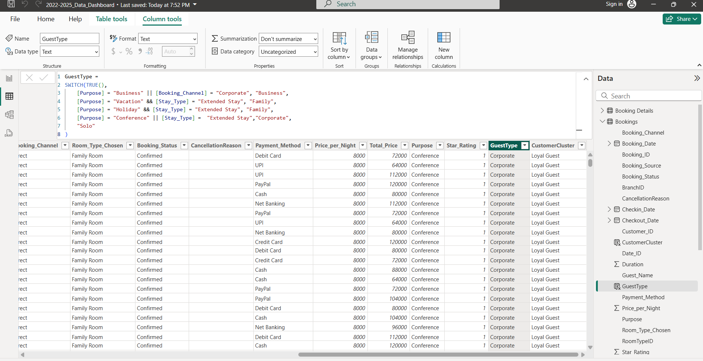

Explanation:
This classification creates Business, Family, Corporate, and Solo traveller categories based on booking channel, purpose, and duration.

2. Creating CustomerCluster (Loyalty & Spend Segmentation)
The CustomerCluster column groups guests based on booking count and total revenue.
DAX Formula:
CustomerCluster =
SWITCH(
TRUE(),
[NumOfBookings] = 1 && [Revenue] < 5000, "First-Timer",
[NumOfBookings] >= 3 && [Revenue] < 15000, "Loyal Guest",
[Revenue] >= 15000, "High Spender",
"Other"
)
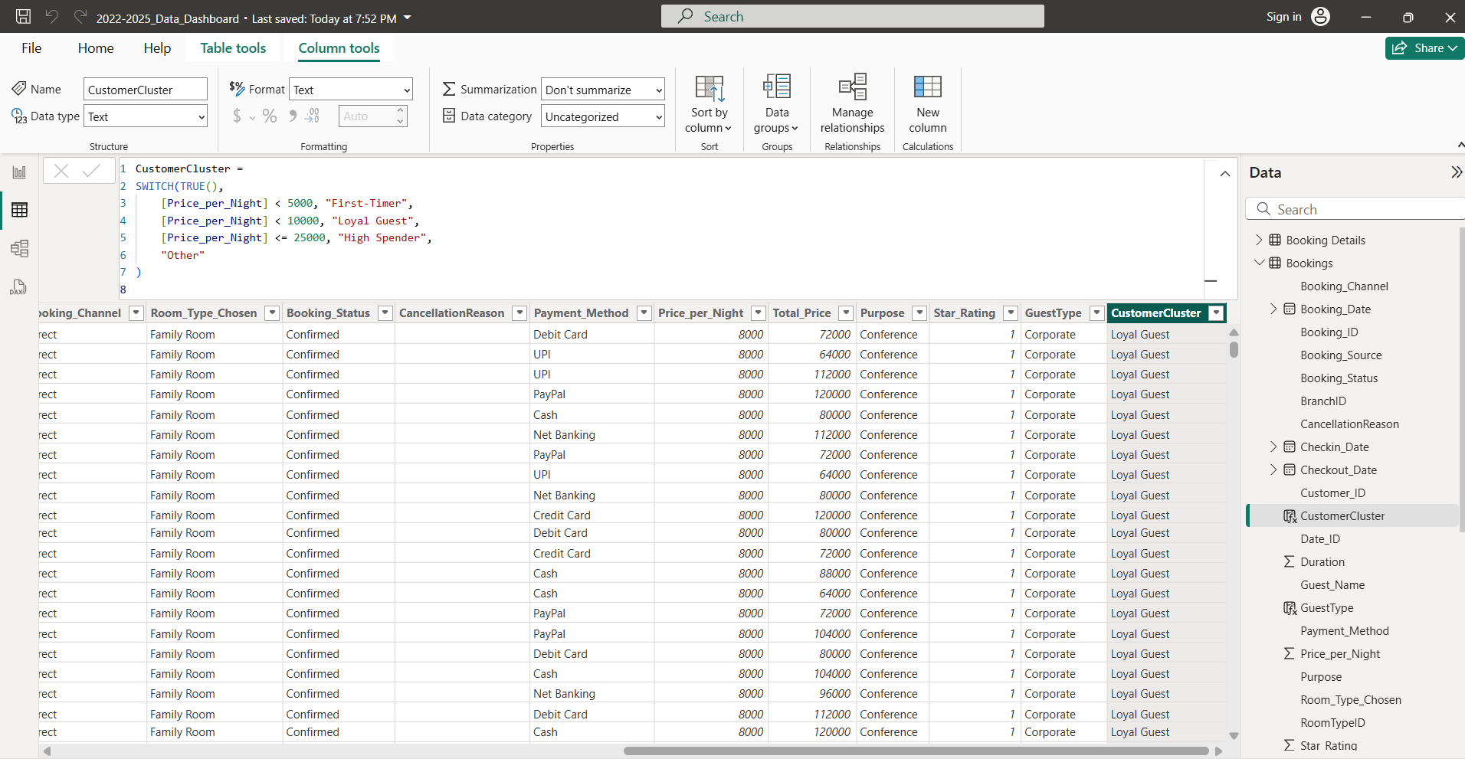
Explanation:
This segmentation identifies First-Time customers, Loyal Guests, High Spenders, and Others.

3. Generating Guest Country (Global Demographics)
A synthetic global country field was created using Excel to diversify customer demographics.
Excel Formula:
=CHOOSE(RANDBETWEEN(1,46),"India","United States","United Kingdom","Canada",
"Australia","Germany","France","Italy","Spain","Brazil","Mexico","China",
"Japan","South Korea","Russia","South Africa","Nigeria","Egypt","Kenya",
"Argentina","Chile","Colombia","Peru","Netherlands","Sweden","Norway",
"Denmark","Finland","Poland","Turkey","Saudi Arabia","United Arab Emirates",
"Israel","Thailand","Vietnam","Indonesia","Malaysia","Singapore","Philippines",
"New Zealand","Pakistan","Bangladesh","Sri Lanka","Nepal","Iran")

4. Guest Summary Table (First Stay – Last Stay)
A summarised guest table (Tbl_Guests) was created to prepare for RFM scoring.
DAX Table:
Tbl_Guests =
SUMMARIZE(
'TblBookings',
'TblBookings'[CustomerID],
"FirstStay", MIN('TblBookings'[CheckInDate]),
"LastStay", MAX('TblBookings'[CheckOutDate])
)

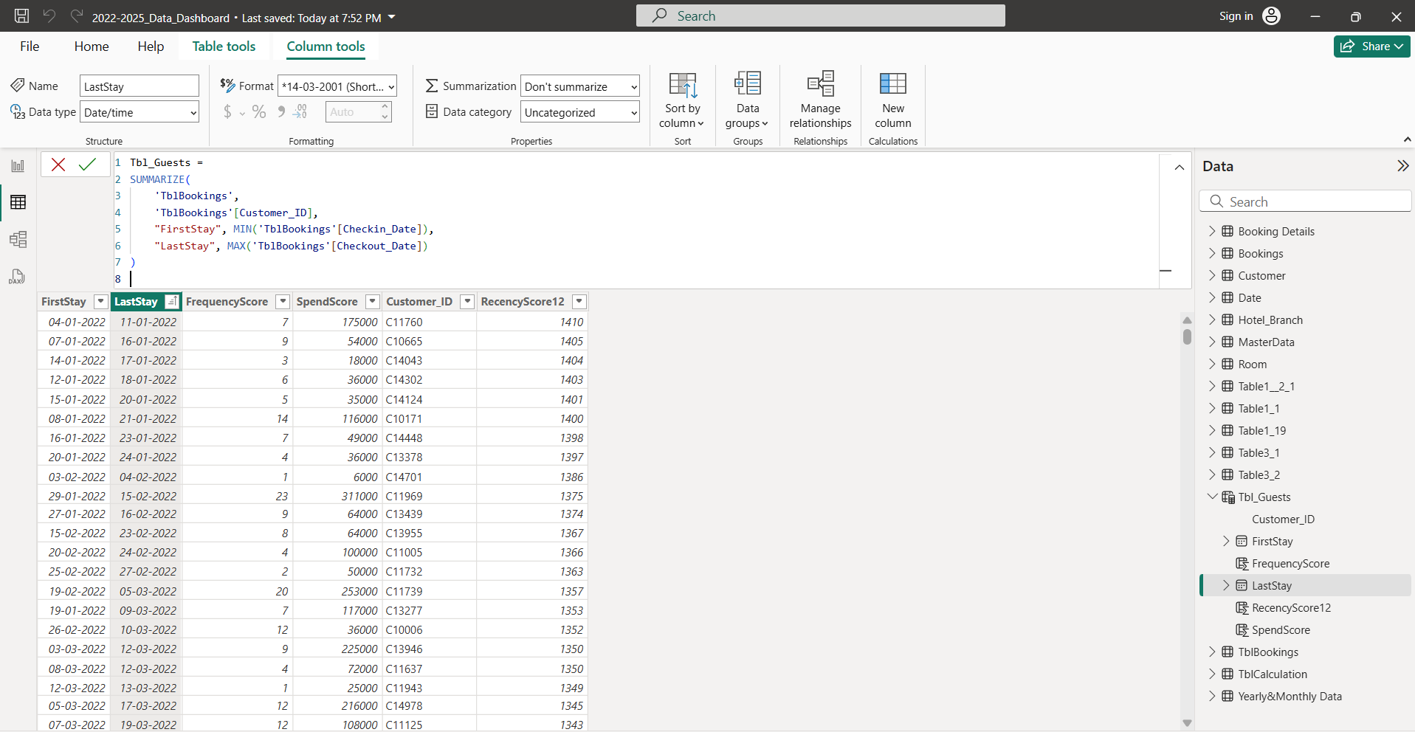

5. Scoring
a) Recency Score
RecencyScore =
DATEDIFF(
CALCULATE(
MAX('TblBookings'[CheckOutDate]),
FILTER('TblBookings','TblBookings'[CustomerID] = 'Tbl_Guests'[CustomerID])
),
TODAY(),
DAY
)
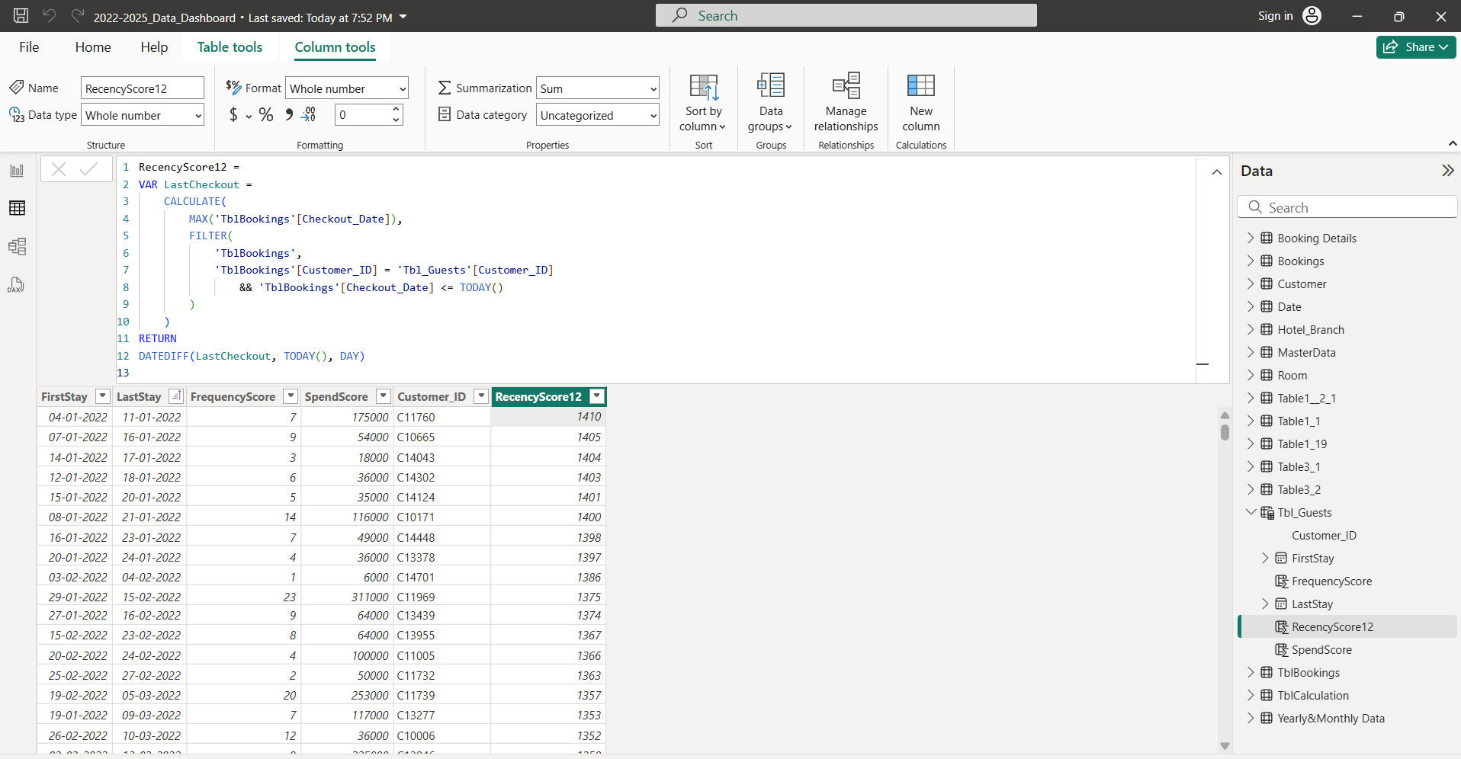

b) Frequency Score
FrequencyScore =
CALCULATE(
COUNTROWS('TblBookings'),
FILTER('TblBookings','TblBookings'[CustomerID] = 'Tbl_Guests'[CustomerID])
)
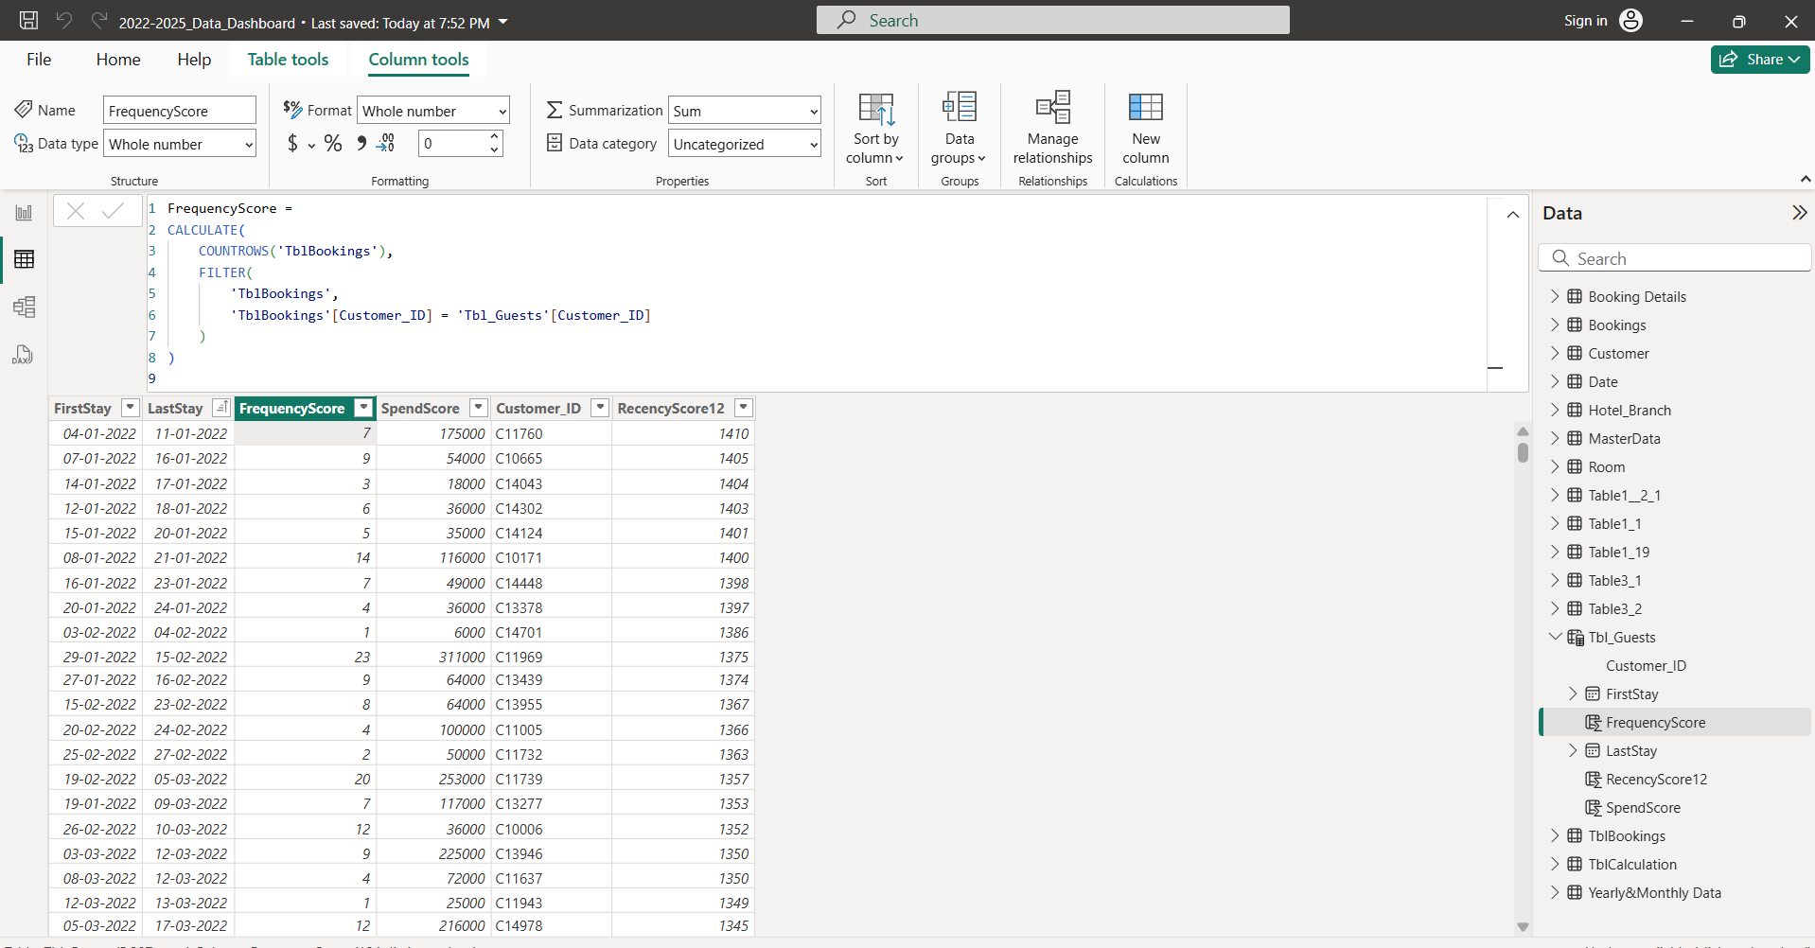

c) Spend Score
SpendScore =
CALCULATE(
SUM('TblBookings'[DayRevenue]),
FILTER('TblBookings','TblBookings'[CustomerID] = 'Tbl_Guests'[CustomerID])
)
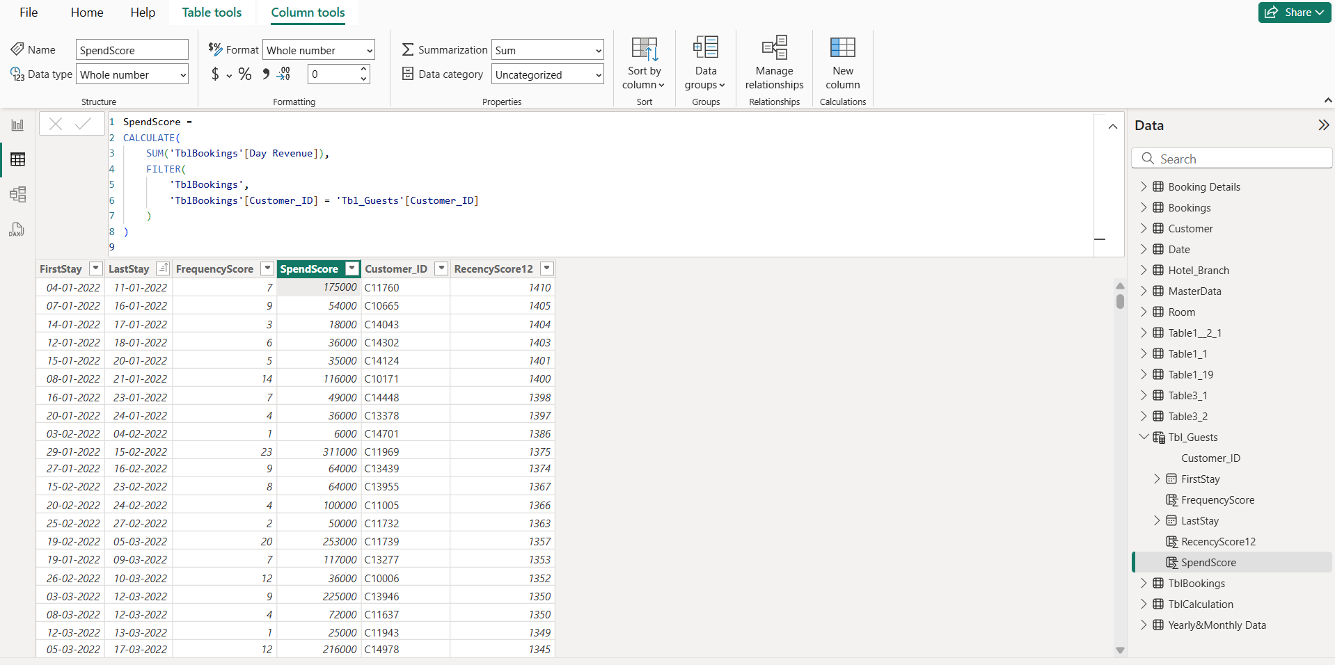

6. Visualisation and Analysis (Module Output)
The following visuals were created in Power BI based on the new customer segmentation attributes such as GuestType, CustomerCluster, Country, Payment Method, Booking Status, and RFM-related fields. These visuals provide a deeper understanding of guest behaviour, nationality trends, booking preferences, payment habits, and global customer distribution.

1. Guest Type – Duration Analysis
This bar chart shows the average duration of stay for Solo, Business, and Corporate guests, helping identify behavioural patterns.
2. GuestType by Nationality
A stacked bar chart visualising the distribution of different guest types across various nationalities.
3. Booking Source Preference by GuestType
This stacked bar chart compares how different Guest Types use booking channels such as Website, Mobile App, Agents, Online Travel Agencies, and Walk-In.

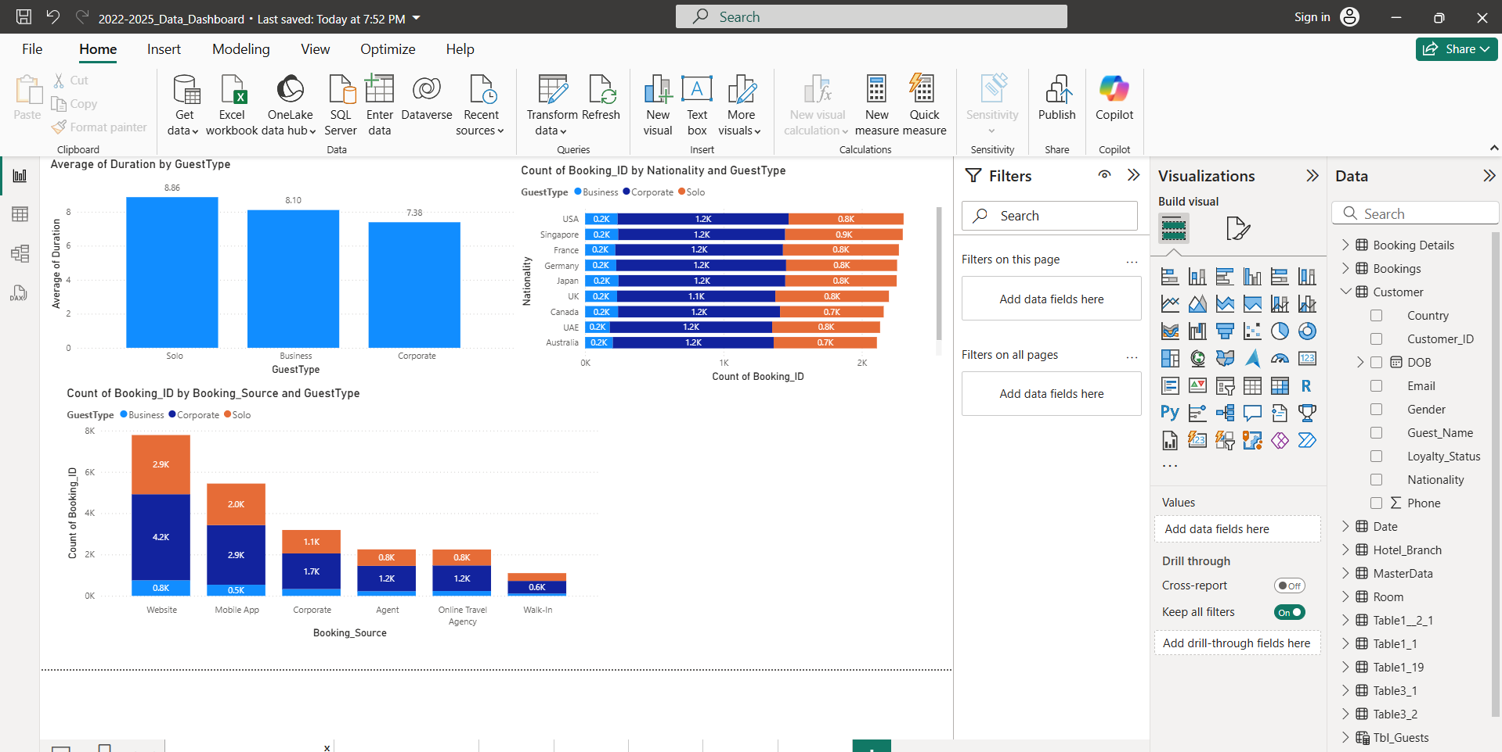

4. GuestType by Booking Channel
A bar chart showing how Solo and Corporate guests prefer Direct vs Corporate booking channels.

5. Global Guest Map
A world map visual showing the distribution of customers across countries, segmented by CustomerCluster.

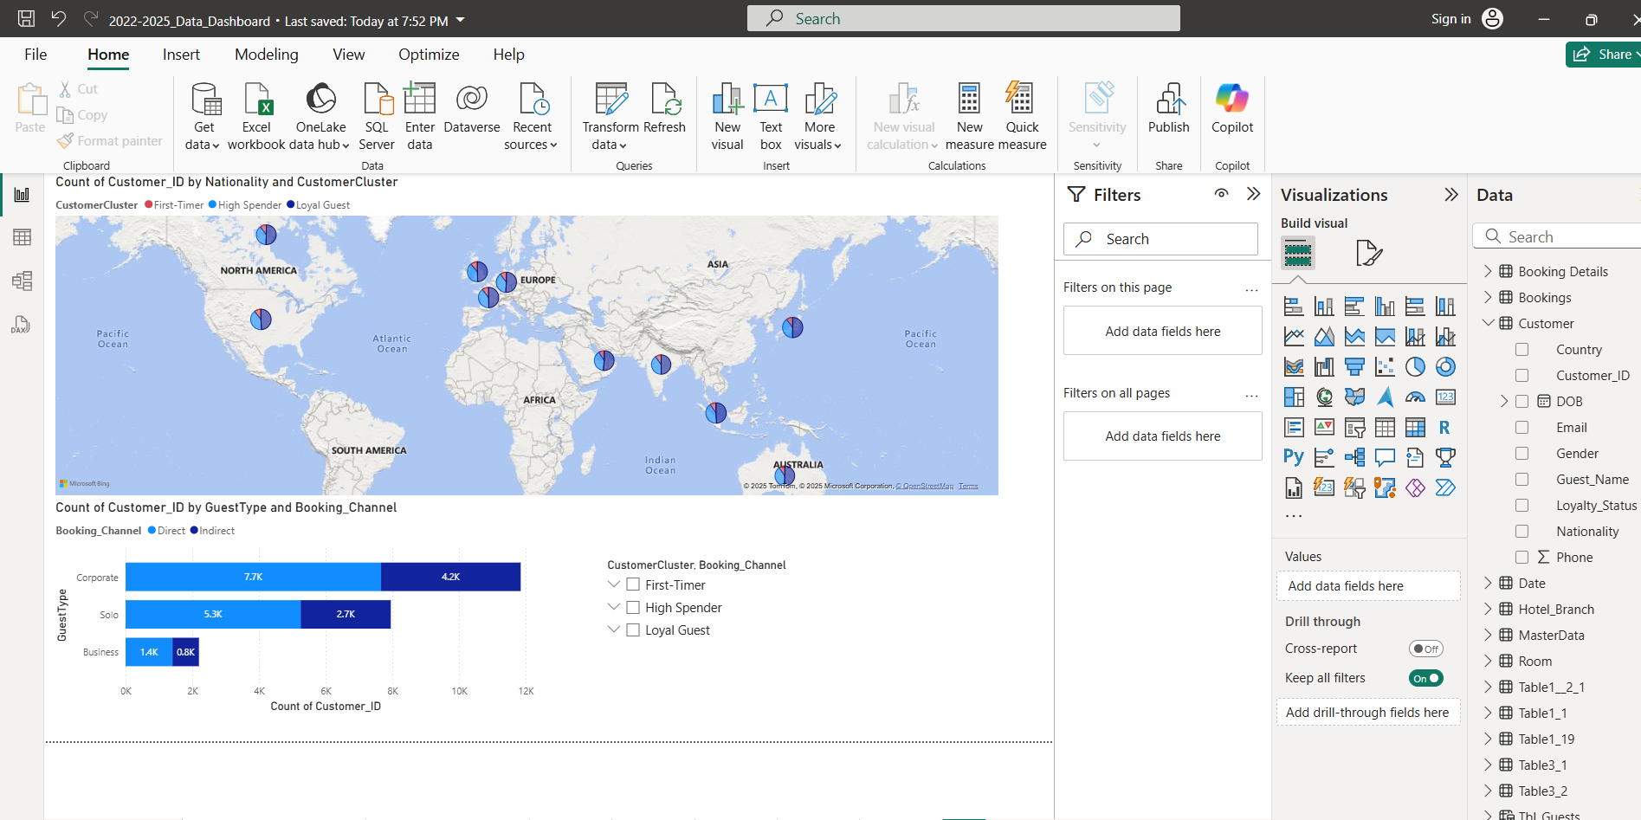
6. Payment Method Distribution by Gender
This pie chart shows how different payment methods (Cash, Credit Card, Debit Card, Net Banking, PayPal, UPI) are used by customers segmented by gender.
This helps analyse customer spending preferences across demographics.
7. Booking Status by Gender
This donut chart shows the distribution of booking statuses (Cancelled, Checked-In, Checked-Out, Confirmed) segmented by gender.
It helps understand operational behaviour and status patterns across customer groups.

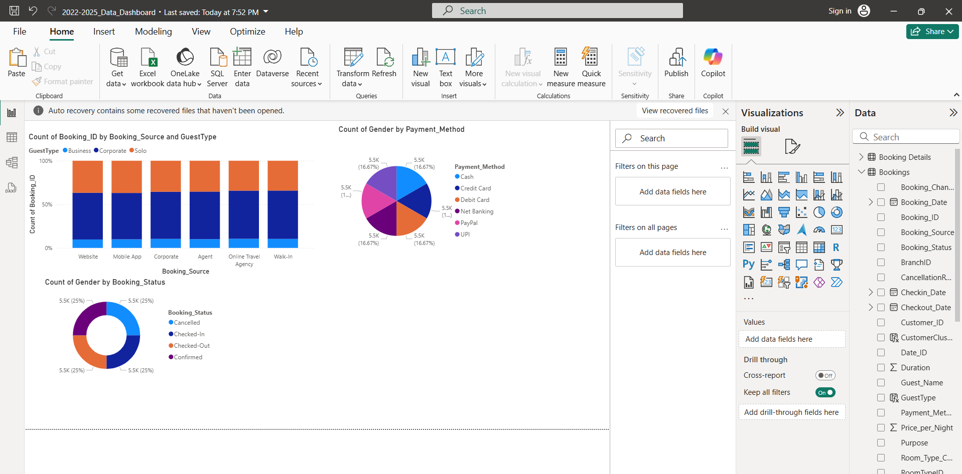

Insights from Module 3
• GuestType analysis shows that Solo, Business, and Corporate guests behave differently, with clear patterns in duration and booking preferences.
• Nationality segmentation highlights a diverse global customer base.
• Direct channels (Website, Mobile App) are the most preferred booking sources across guest types.
• High Spenders and Loyal Guests contribute significantly to revenue and repeat business.
• Gender-based payment and booking status visuals reveal consistent behaviour across payment methods and stay outcomes.
• Recency scores help identify customers likely to churn, supporting retention strategies.
• The global map visualization confirms strong international demand, enabling targeted marketing.
.

Conclusion
Module 3 adds powerful customer intelligence layers to HotelRevAI.
By integrating GuestType, CustomerCluster, country mapping, and RFM scoring, this module supports deep behaviour analysis, improves targeting, and boosts revenue decision-making.

